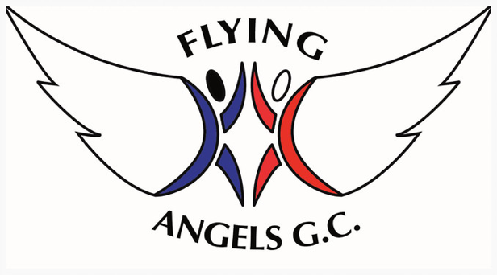
Welcome everyone to our official newsletter!

Flying Angels Gymnastics Club
Term Dates
Term 2 – 6th January 2020 – 4th April 2020
Term 3 – 20th April – 25th July 2020
Bake Sale Dates –
9th – 14th March 2020
We are closed for Easter Break from 6th – 19th April
Please remember we do run through half terms.
  - Issue 8
02/03/2020
Welcome to our official March newsletter! We have been working very hard this term for our upcoming Cheam Competition.
Cheam Competition
The last couple of months we have been working extremely hard towards are Invitational Competition at Cheam Gymnastics Club. All of the children selected have been given a routine to learn and a vault to practice. We are all so pleased with how hard everyone has been working towards this. . Just a reminder that the Competition is on Sunday 8th March 2020. Good luck to all Gymnasts and Coaches!
Competition Groups
We just want to make Parents/Carers aware that if your child is in a 2+ hour group they are in a Competition group and therefore are required to compete. The Competition’s we get invited too are so much fun and are a great way for Parents to see progress.
Stars of the month
Every month the coaches will discuss who they think has worked exceptionally hard or has learned a new skill. All the coaches are proud of you all. This month the stars of the month are:
Lucy Rose-Raynes, Maisie Marshall and Elizabeth Mackenzie Ross for doing their Giants by themselves on the metal bar.
Elizabeth Mackenzie Ross for learning her round off flick on floor.
Alexandra Periera for getting her straddle undershoot dismount on bars.
Stephanie Keenan for consistently coming to train and is so close to doing her upstart on bars.
Montoye Baker for working extremely hard towards her half on half off on vault.

British Gymnastics Membership
Please can all members remember to register for your child/children’s British Gymnastics Membership via their website please. This is MANDATORY.
Anyone found without a valid British Gymnastics Membership will now not be allowed to enter the gym.

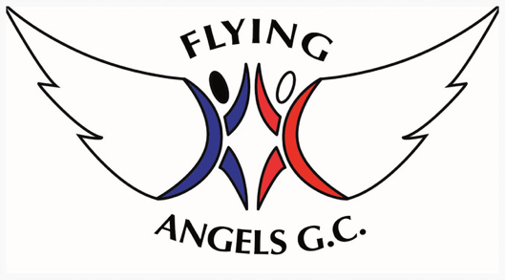
Club Uniform
It is essential that all gymnasts have the correct club uniform. This includes t-shirts, hoodies and Competition leotards. This can be bought at our front desk.

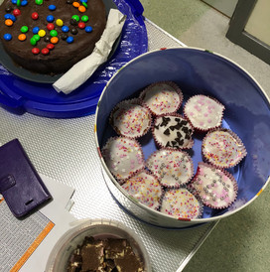
Bake Sale and Fundraising
We are 25% closer to our target of £3,000 for our mini apparatus. Thank you to everyone who has helped us so far, please keep up the good work! We are holding another bake sale next 9th – 15th March. If you could all help us out by bringing in baked goods If this is something you can’t do we also have a JustGiving Page here and we have a money box at the gym.
Flying Angels Gymnastics Club
Bishop Thomas Grant School
Belltrees Grove
Streatham
London SW16 2HY
flyingangels_gymclub@hotmail.co.uk
07951833520

